INTENSIVE CARE SCHOOLS WANDI

PRE-MOCK SETS

EXAMINATION 2024
Mathematics

Time: 2 hours 30 minutes

NAME: ___________________________________________________

Signature: _________________________________________________

Read the following instructions carefully:
- This paper is made up of section A and B.
- Section A has 20 short answer questions (40 marks).
3. Section B has 12 questions (60 marks).
4. All answers to both section A and B must be written in the spaces provided.
5. All answers must be written in blue ink and diagrams should be drawn in pencil.
6. Any handwriting that cannot easily be read will lead to loss of marks.
7. Unnecessary alteration of work may lead to loss of marks.
8. No calculators are allowed in the examination room.

FOR EXAMINER’S USE ONLY

A
B
TOTAL

SECTION A:(40 Marks)

1. Work out: 59 – 32

2. Write 340,096 in words.

3. Simplify: ¯8 – ¯3

4. Find the next number in the sequence: 1 , 2 , 6 , 15 , 31 , _______

5. Solve: n – n = 12
5

6. In the Venn diagram below, find n(X – Y)ʹ.
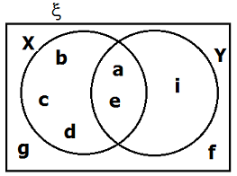

7. Simplify: 4n⁵ x 3n
6n⁴

8. A fruit seller buys 15 apples for sh. 18000. He sells them at sh. 1500 each. Find his profit.

9. The circumference of a circle is 88 m. Find its radius. (Take π = ²²/₇)

10. A test which took 1 hour 15 minutes ended at 3:40 p.m. What time did it start?

11. Write 0.025 as a fraction in its simplest form.

12. Express CDXCIV in Hindu - Arabic numerals.

13. A box contains 20 balls of which some are white and others are red. The probability of picking a red ball is ²/₅. Find the number of white balls.

14. Find the value of xy – z if x = -2, y = -3 and z = -4

15. Using a pair of compasses, a ruler and a pencil only, construct an angle of 75º in the space below.

16. In the figure below, find the size of angle k.
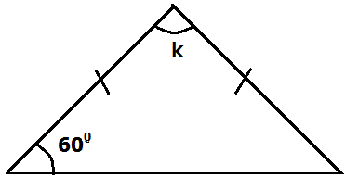

17. A trader bought a shirt for sh.6000 and sold it for sh.7200. Find his percentage profit.

18. Find the largest number that can divide 18 , 27 and 36 without leaving a remainder.

19. The following are masses of six boys in a P.6 class: 42kg , 44kg , 48kg , 40kg , 49kg and 42kg. Find the median mass of the boys.

20. A school planted trees in a straight line along one side of a road leading to the school. The road is 540m long and the interval between the trees is 5m. How many trees were planted altogether?

Section B: (60 marks)

21(a) Write 23 in base two. (2 marks)

(b) How many times is the value of digit 3 more than the value of digit 4 in the number 836,146? (3 marks)

22. In a class, 24 pupils drink Soda (S), (k + 6) drink Mineral water (W) only, 13 drink both soda and mineral water while (k – 5) drink neither of the two types of drinks.
(a) Use the information above to complete the Venn diagram below. (2 marks)

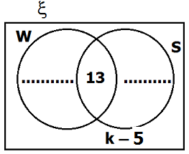

(b) Given that 23 pupils do not drink soda, find the value of k. (2 marks)

(c) Find the total number of pupils in the class. (1 mark)

23(a) Using a pair of compasses, a ruler and a pencil only, construct a triangle PQR in which QR = 6cm, angle PQR = 120⁰ and angle QRP = 30⁰. (4 marks)

(b) Measure PR (1 mark)

24(a) Simplify: 1 ½ x 1 ¹/₉ – 3 ⁹/₁₀ ÷ 3 ³/₅ (3 marks)

(b) Work out: 0.72 x 0.35 (3 marks)
0.15 x 1.2

25(a) Solve the equation: 3 – (y – 1) = 2( y + 5) (3 marks)

(b) Find the solution set for the inequality: 7 ≥ 1 – 2n (3 marks)

26. The exchange rates in a bank are as follows:

1 US dollar ($) = Ug sh 3800
1 British Pound Sterling (₤) = Ug sh. 5200
1 Kenya shillings (K.sh) = Ug sh 39

(a) Convert $ 250 to Uganda shillings. (2 marks)

(b) If a motorcycle costs ₤ 600, find the equivalent cost of the motorcycle in Kenya shillings. (3 marks)

27. The diagonal of the rectangle below is 20cm and the width is 12cm. Calculate the area of the rectangle. (4 marks)
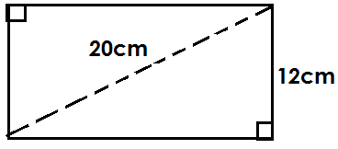

28. Study the figure below and use it to answer the questions that follow.
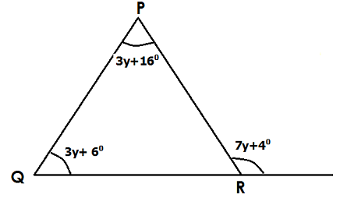
a) Find the value of y. (3 marks)

(a) Find the value of y. (3 marks)

(b) Calculate the size of angle QRP. (2 marks)

29(a) A motorist covers 240 Km in 2 hours 40 minutes. Calculate the average speed of the motorist in Km per hour. (2 marks)

(b) A cyclist travelling at a speed of 40km per hour left town A at 8:35 a.m. for town B. If the distance between A and B is 60 km, at what time did the cyclist reach town B? (3 marks)

30. The price of a television set was increased by 20% to sh.600,000.

(a) Find the old price of the television set. (3 marks)

(b) If the new price is reduced by 8%, find the decrease in the price. (1 mark)

31. Fifty books were loaded in a carton weighing 1.5kg. If each book weighs 300g, find the mass of the carton and the books in kilograms. (4 marks)

32. The pie chart below shows the people who attended a football match. Use it to answer the questions that follow.
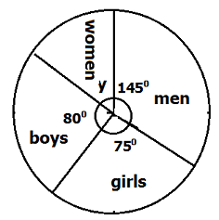

(a) If 720 women attended the match, find the total attendance. (4 marks)

(b) How many males attended the match? (2 marks)

BY Tr. BABEL END

